**Global AI Content and Impact Dashboard – Power BI Data Visualization Project**

**About the Project**

This project investigates the growing impact of artificial intelligence across industries and regions using Power BI. I visualized how AI adoption correlates with content volume, workforce shifts, consumer trust, and company market share. Using built-in Power BI functions and visuals, I created an engaging and data-rich dashboard that compares countries, industries, and popular AI tools. I avoided custom DAX and instead relied on default aggregations like Sum and Average to keep the dashboard efficient and interpretable.

**Goal**

The goal of this dashboard is to uncover patterns in AI-generated content production, job loss, revenue impact, and market behavior by visualizing global adoption trends. It helps inform decision-makers about which sectors and regions are leading or lagging in AI-driven transformation.

**Technology**

**Tools**: Power BI  
**Skills**: Data Visualization, Interactive Dashboard Design, Comparative Analysis, Aggregation Using Power BI

**Sum of AI-Generated Content Volume (TBs per year) by Industry**I created a line chart to show the total volume of AI-generated content per year, grouped by industry. I used Power BI’s built-in Sum aggregation to display how sectors like Gaming, Media, and Education lead in AI content production, while Finance and Marketing show lower volumes.

**Sum of AI Adoption Rate (%) by Country**  
I inserted a map visual to present AI adoption rates across countries. Using Power BI's Map visualization, I plotted countries based on their summed AI adoption percentages, showing visually which regions lead or lag in AI implementation.

**Sum of Job Loss Due to AI (%) and Sum of AI Adoption Rate (%)**  
I used a donut chart to compare the total percentage of job loss due to AI with the overall AI adoption rate. I placed both values in the values field using Power BI’s default Sum function, which enabled a side-by-side visual of these two metrics for comparative impact.

**Sum of AI-Generated Content Volume (TBs per year) by Country**  
I built a clustered column chart showing the total volume of AI-generated content across different countries. I used the Sum aggregation to calculate total content volume and grouped it by country, revealing that France, China, and India lead in AI-generated content output.

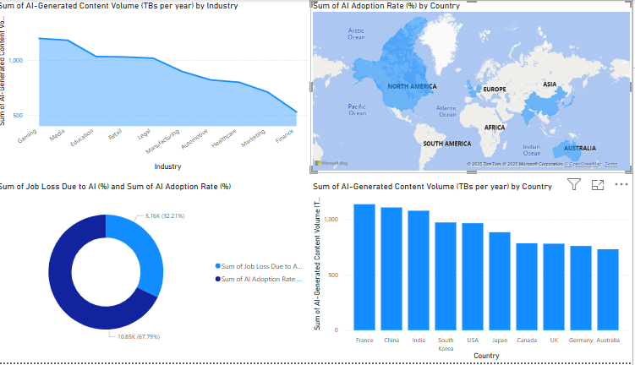

**Sum of Revenue Increase Due to AI (%) by Country**  
I created another map visual to present the total percentage increase in revenue attributed to AI across countries. I used the Sum function to aggregate values and applied conditional shading to highlight regional differences.

**Average of Human–AI Collaboration Rate (%), AI-Generated Content Volume, and Consumer Trust in AI by Top AI Tools Used**  
I designed a grouped bar chart comparing three different metrics: human–AI collaboration rate, AI-generated content volume, and consumer trust in AI for each top AI tool (e.g., DALL·E, ChatGPT, Claude). I used Average aggregation in Power BI for all metrics and layered the chart to allow clear comparison across tools.

**Average of Market Share of AI Companies (%) by Regulation Status**I used a line chart to analyze how the average market share of AI companies varies with different regulation environments (Strict, Moderate, Lenient). I applied Average aggregation on market share and placed regulation status on the X-axis to visualize regulatory impact.

**Average of Consumer Trust in AI (%) by Top AI Tools Used and Industry**  
I created a treemap to show consumer trust levels in AI, broken down by both AI tool and industry. I used Average aggregation to measure trust levels and added two category fields AI Tool and Industry to visually segment the results.

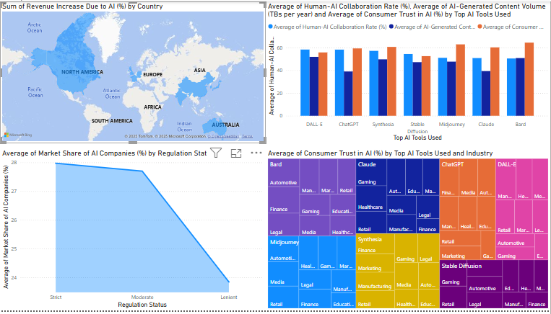

**Conclusion**

This Power BI dashboard helped me gain insight into how AI adoption influences industries, economies, and public perception worldwide. It allowed me to enhance my skills in visual storytelling and interactive business intelligence without relying on DAX.